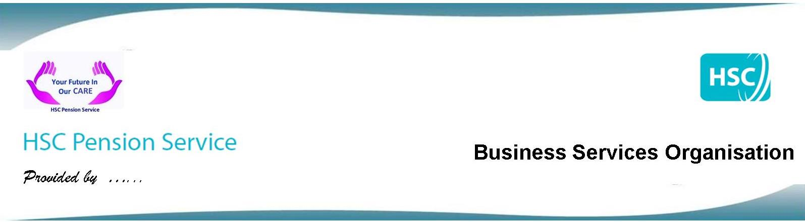
Public Service Pensions - Consultation:
- The Department of Finance is currently consulting on proposals to fix age related discrimination identified in the transitional arrangements of the 2015 public service pensions’ reforms.

- This consultation will come to an end on 18 November and you are encouraged to have your say.

- Individuals do not need to make any decisions on their own pension arrangements at this point, DoF is simply seeking your views on the best way to remove the discrimination.

What does it say?
- The consultation explains that under both proposals affected individuals will receive a choice of which pension scheme they would prefer to be in for the period in which the discrimination took place; this is between 1 April 2015 and 31 March 2022.
- The consultation is seeking views on when members should be given that choice.
- The proposals set out that this will either be shortly after implementation (i.e. from 2022 onwards) or when individuals reach retirement. Further details of both options including the advantages and disadvantages of both are set out in the consultation.
- After 2022, all members will automatically be moved into the reformed schemes regardless of their age.

Who is affected?
- Anyone can respond to the consultation, but DoF especially encourages those who are affected to share their views.

- To help individuals understand whether they are affected by these changes, the diagram below sets out the criteria.
Were you in service as a member of a public service pension scheme on or before 31 March 2012 and on or after 1 April 2015?
No
Yes

You are not affected (unless you held a right to return within 5 years to your previous scheme on 31 March 2012).
Have you retired or are you planning to retire (including partially) before 1 April 2022?

Yes
No

You will receive a choice between old and new scheme benefits for service between 2015 and your retirement date.
You will receive a choice between old and new scheme benefits for service over the period 2015-22.

What happens next?
- Once the consultation closes on the 18 November, DoF will consider all responses and publish its response in due course.

- Please be assured that if you are a member who is already being affected by this, i.e. retired, part retired, or suffering ill-health, your case will be prioritised. HSC Pension Service will be in contact as soon as they are able to process cases.

