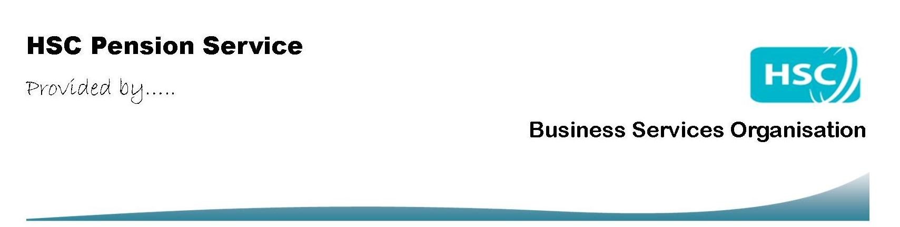

HSC Pension Scheme Waterside House
75 Duke Street
Derry
BT47 6FP
Your address:

Early Retirement Reduction Buy Out (ERRBO)
Expression of interest
(For 2015 Scheme members only)

Before completing this form please read the ERRBO factsheet, which is available on our website at http://www.hscpensions.hscni.net/

About you

Surname

First names

NI number

Date of birth / /

Name of employer

Start date of current
employment / /

I have read the factsheet and believe I may be eligible to purchase an ERRBO. Please provide details of the cost and amount available to purchase.

Your signature

Today’s date / /

