HSCPS Annual Report 2022-2023

HSCPS Annual Report 2022-2023

Table of contents
- The Pension Board Purpose and Role 3
- The HSC Pension Scheme 7
2.1 Pension Administration Team
2.2 Payroll Pension Team
2.3 Annual Allowance Team
2.4 Data Management Team
2.5 Trust Liaison Team
2.6 GP Practitioners Team
2.7 IDR2s and PO Outcomes

Appendix A - Record Keeping; data improvement
Appendix B - Organisational Chart

- Governance……………………………………………………………………………….... 35
3.1 Risk Management
3.2 Reporting to the The Pensions Regulator (TPR)
3.3 Membership changes to Pension Board
3.4 Pension Board Training P

HSC Pension Board
The HSC Pension Board provides scrutiny and assurance of the administration of the HSC Pension Scheme.
Role of the Board
The HSC Pension Board’s role is to assist the Scheme Manager in securing compliance with all relevant pension law, regulations and directions – as well as the relevant Pension Regulator’s codes of practice. This role is one of providing assurance in and governance of the scheme administration of the HSC Pension Schemes (both the new 2015 scheme and the old scheme consisting of the 1995 and 2008 sections).
Main responsibilities:
The Pension Board is responsible for assisting the Scheme Manager in:
- Providing overall assurance and governance of the HSC Pension Scheme administration;
- Assuring effective and efficient administration of the scheme;
- Seeking assurance that decisions made by the scheme administrator are fully legally compliant, including consideration of cases that have been referred to the Pension Regulator and/or the Pension Ombudsman; recommending changes to processes training and / or guidance where necessary;
- Supporting continuous improvements;
- Assuring the scheme administrator supports employers to communicate the benefits of the HSC Pension Scheme through effective communication to members;
- Assuring the scheme administrator supports members with a range of tools to improve their understanding of their pension benefits and to inform their personal financial and career planning;
- Supporting effective implementation of the Employer Charter;
- Enabling data quality improvements to deliver CARE pension outcomes;
- Compliance with the Pension Regulator’s codes of practice;
- Fostering good working relationships with the Pension Regulator;
- Consideration of the annual report from the Pension Regulator, including any responses to recommendations;
- Producing an annual report outlining the work of the Board throughout the scheme year.
A Terms of Reference (ToR) is maintained by the Pension Board
Membership
The Pension Board has an equal number of employer and member representatives and is overseen by an independent chair.
Pension Board members are appointed after being nominated by HSC trades unions and employer organisations.
Non employer/member representatives such as Department of Health officials and HSC Pension Service representatives attend Pension Board meetings in an observer capacity.
Chair
The current independent chair is Paul Cummings
Employer Representatives
Noeleen McCreanor | SE Trust
Andrea Henderson | SPPG
Maryna Chambers | Northern Trust
Cara McLaughlin | Western Trust
Catherine Shannon | Belfast Trust
Alan Stout | NIGPC
Member Representatives
Kevin McAdam | UNITE
Sam Stone | BMA
Terry Thomas | NIPSA
Desmond Lowry | RCN
Karen Murray | RCM

Annual Update from Independent chair

To follow
Delighted to be appointed
Thanks to David Best
Thanks to PB for support throughout the year – and previous members.
Welcome new members
Highlight successes – McCloud OBC, New senior structure, Compliance officer/secretariat, Scheme Compliance, Customer survey
Challenges – implementation McCloud, New Legislation, Tax Changes AA/LTA, Training new staff re McCloud, accommodation
Looking forward – addressing challenges, good attendance, training needs analysis Board, working with DoH, GAD,HMRC – taxation and compensation.

Insert exec summary – refer to BSO annual Report – Headshots SPT

2. The HSC Pension Scheme

  - Pension Administration Team 22/23
Scheme Activity | Annual 21/22 | Quarter 1 | Quarter 2 | Quarter 3 | Quarter 4 | Annual  22/23 | KPI
Payments | 502,070 | 130,725 | 133,334 | 134,805 | 136,931 | 535,795 | 100%
Retirements | 2857 | 1,401 | 1,150 | 874 | 738 | 4,163 | 100%
Estimates | 3504 | 767 | 997 | 879 | 1,054 | 3,697
Refund | 560 | 204 | 173 | 344 | 399 | 1,120 | 100%
Transfers | 281 | 60 | 315 | 434 | 647 | 1,456 | 100%
FPC Charges* | 60 | 7 | 3 | 2 | 0 | 12
OHS Referrals | 346 | 89 | 84 | 45 | 83 | 301 | 100%
Telecall’s Rec’d | 21,610 | 6,386 | 5,895 | 4,719 | 6,228 | 23,228

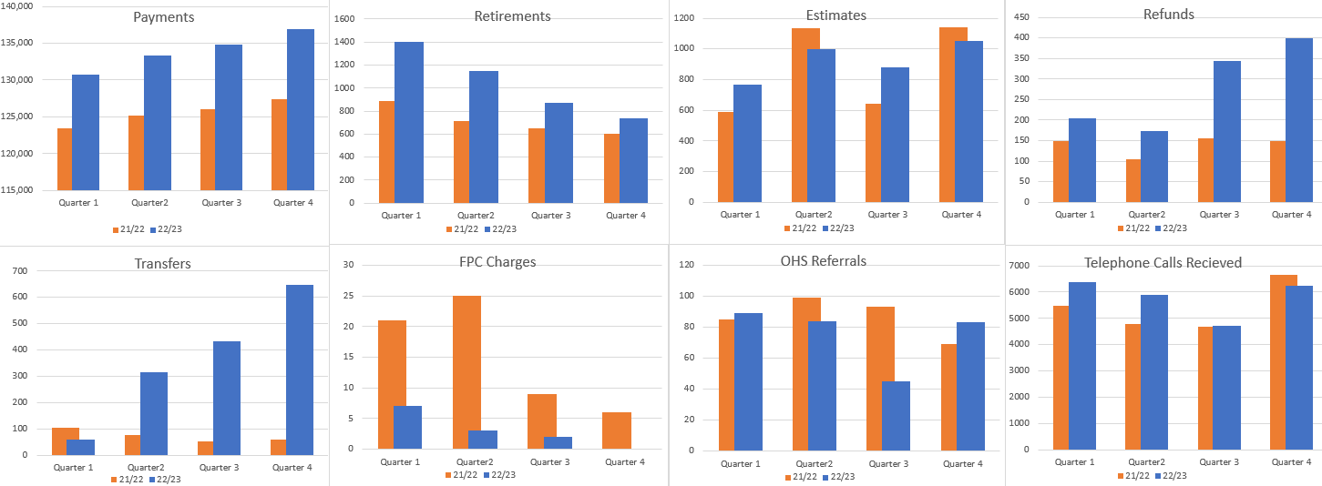

SCHEME GROWTH | 31.03.13 | 31.03.22 | 31.03.2023 | Growth % in last 10 years
Active Members | 57,756 | 91,528 | 79,554 | 38%
Deferred Members | 15,479 | 12,417 | 11,616 | -25%
Pensioners & dependents | 28,771 | 42,597 | 41,781 | 45%
Total | 102,006 | 146,542 | 132,951 | 30%

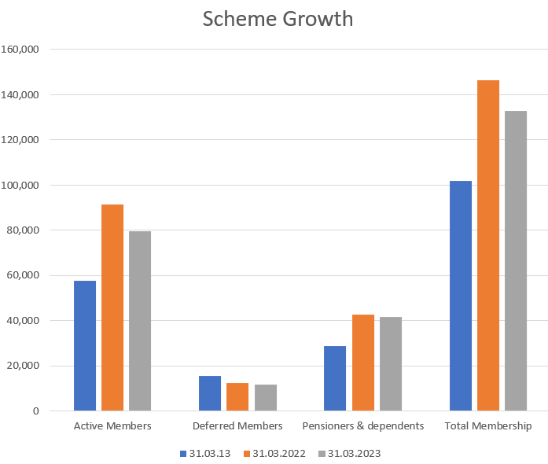

  - Payroll Pension Team
The PPT Team is responsible for managing a number of pension related processes including Pension Benefit applications and Estimate of Benefit applications. This includes the calculation of Final Salaries, length of service and part time and additional hours across a range of multiple employments and contracts.
Activity | Annual 2021/22 | Quarter 1 | Quarter2 | Quarter 3 | Quarter 4 | Annual 2022/23
Retirement applications | 1790 | 516 | 376 | 423 | 392 | 1707
Death Benefit app | 43 | 18 | 20 | 16 | 18 | 72
Estimate of  benefits | 1428 | 269 | 322 | 484 | 374 | 1449
CETVs  Cash eq tran value | 211 | 73 | 54 | 63 | 55 | 245
Leaving salaries T55As | 2297 | 452 | 582 | 1008 | 2249 | 4291
General queries | 1905 | 352 | 366 | 297 | 607 | 1622
Protect of Pen Pay | 12 | 1 | 5 | 2 | 5 | 13
Benefit Revisions |  | 0 | 30 | 12 | 136 | 220
Tapered protection | 412 | 0 | 0 | 0 | 0 | 0

Pension Payroll Team Activities - 2022/2023

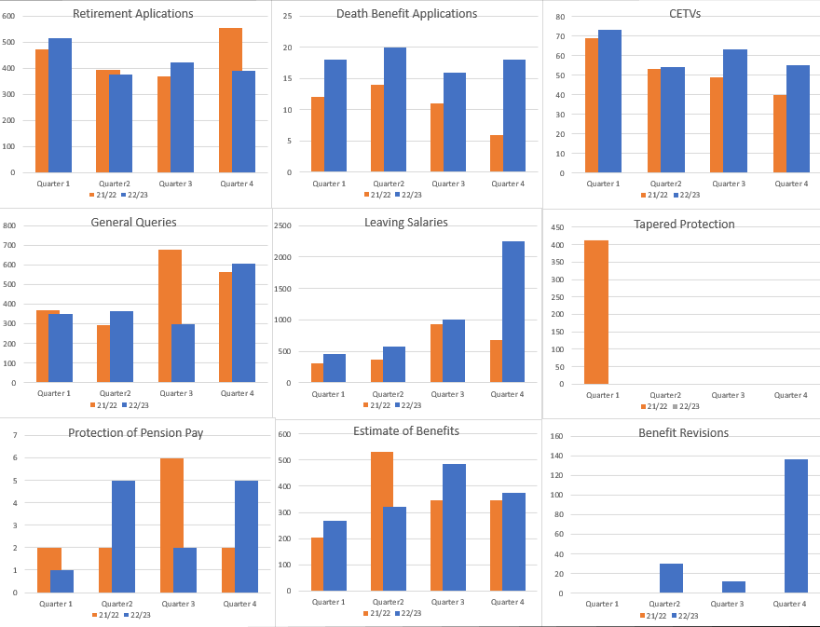

  - Annual Allowance Team
The Annual Allowance Team is responsible for the calculation of Annual Allowance (AA) for all scheme members and respond to tax related queries relating to pension growth and the impact of the Lifetime Allowance (LTA). The team is also responsible for informing any member who has breached the Annual Allowance limits within the required timeframes in accordance with statutory legislation.

Below are details of the work completed this financial year by the team:

Area of Activity | Quarter 1 | Quarter 2 | Quarter 3 | Quarter 4 | YTD
Annual Allowance | 998 | 1612 | 1211 | 918 | 4739
Telephone Queries | 94 | 114 | 145 | 97 | 450
E-Mail Queries | 217 | 415 | 691 | 489 | 1812
1-1 consultations | 55 | 62 | 111 | 54 | 282

Annual Allowance Activities - 2022/2023

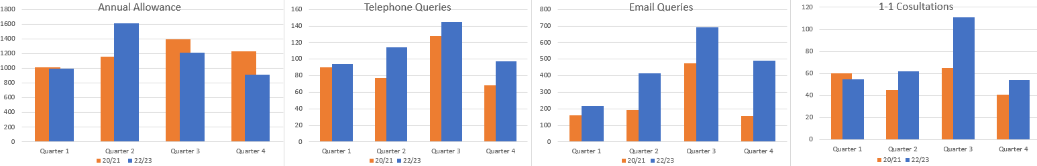

  - Data Management Team
HSCPS have plans in place to roll out Member Self service to all users, including deferred and pensioner members via a proxy server. This will allow all Scheme members to access their pension data on line without the need for access to HSC networks.
The Data Management team continue to work with Payroll Shared Services Centre (PSSC) staff to quality assure the monthly data files received from PSSC.
The team are now preparing for the 2023 Annual file from PSSC and HSC Employers and Directional Bodies and preparing the bulk calculation for the 2023 Annual Benefit Statements.
  - Trust Liaison Team
The Trust Liaison Team work side by side with Employers to provide assistance where needed with complex queries as well as training for HR staff. In particular this year training has been delivered to Trust HR teams in relation to the complexities of the HSC Pension Scheme such as, impacts of McCloud Remedy, Protection of Pensionable Pay and Ill Health Retirement. Further sessions are planned for 2023/24. The team is also responsible for the communication of all updates in legislation as well as other points of interest to staff and employers.
McCloud specific workshops continue to be delivered across all Trusts/Organisations and are addressing the majority of concerns raised and continue to positive feedback as evidenced in our Customer Surveys.

Below are details of the work completed this financial year by the team:
 | Annual | Quarter 1 |  | Quarter 2 |  | Quarter 3 |  | Quarter 4 |  | Annual
Employer | 2021/22 | No. | Attended | No. | Attended | No. | Attended | No. | Attended | 2022/23
BHSCT | 29 – 983 | 5 | 228 | 3 | 130 | 7 | 237 | 6 | 129 | 15 – 595
WHSCT | 18 – 345 | 4 | 74 | 2 | 34 | 4 | 69 | 5 | 52 | 10 – 177
SHSCT | 19 – 457 | 4 | 80 | 3 | 80 | 2 | 41 | 4 | 72 | 9 – 201
SEHSCT | 18 – 346 | 4 | 122 | 2 | 43 | 4 | 96 | 4 | 62 | 10 – 261
NHSCT | 17 – 602 | 5 | 167 | 5 | 151 | 3 | 73 | 5 | 126 | 13 – 391
BSO | 10 – 167 | 3 | 78 | 7 | 85 | 2 | 35 | 5 | 209 | 12 – 198
NIAS | 6 – 84 | 1 | 11 | 2 | 9 | 1 | 11 | 1 | 11 | 4 – 31
HSC Wide | 6 – 777 | 0 | 0 | 2 | 78 | 2 | 170 | 1 | 205 | 4 – 248
Total | 124 - 3761 | 26 | 760 | 26 | 610 | 25 | 732 | 31 | 866 | 108 - 2968

HSC Pension Scheme Member Workshops Delivered - 2022/2023

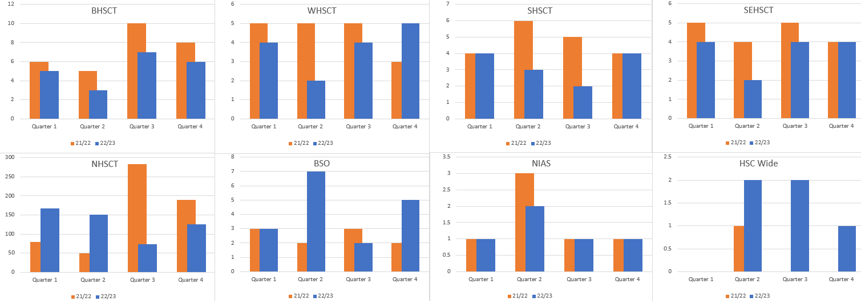

HSC Pension Scheme Member Workshop Attendees - 2022/2023

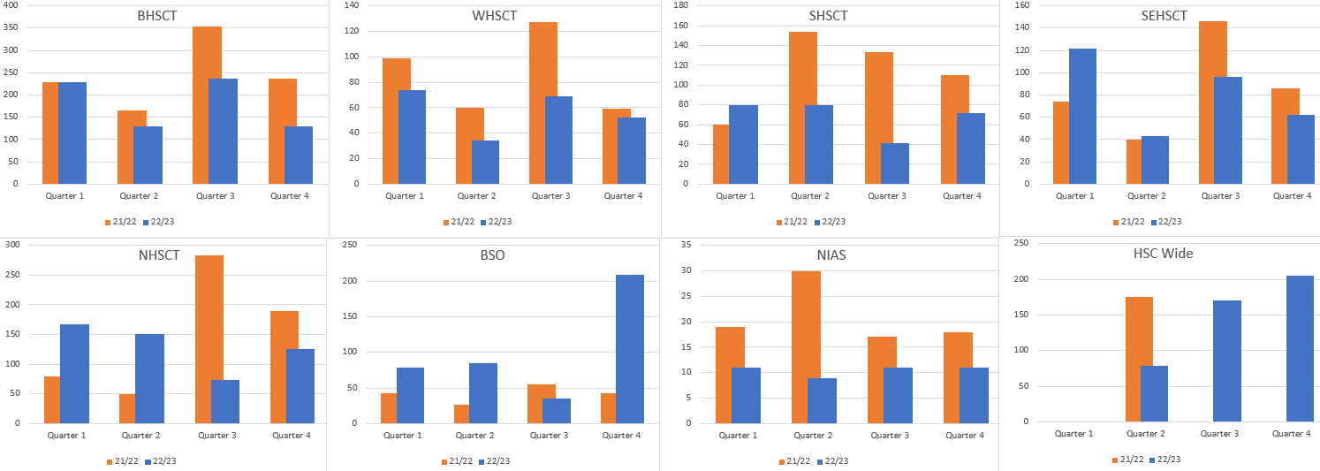

One to One Consultations

 | Annual 2021/22 | Quarter 1 | Quarter 2 | Quarter 3 | Quarter 4 | Annual 2022/23
Employer
BHSCT | 226 | 36 | 31 | 29 | 53 | 149
WHSCT | 96 | 22 | 20 | 25 | 35 | 102
SHSCT | 128 | 30 | 27 | 11 | 36 | 104
SEHSCT | 122 | 24 | 4 | 8 | 25 | 61
NHSCT | 169 | 42 | 16 | 19 | 44 | 121
BSO | 61 | 15 | 10 | 7 | 17 | 49

One to One Consultations 2022/2023

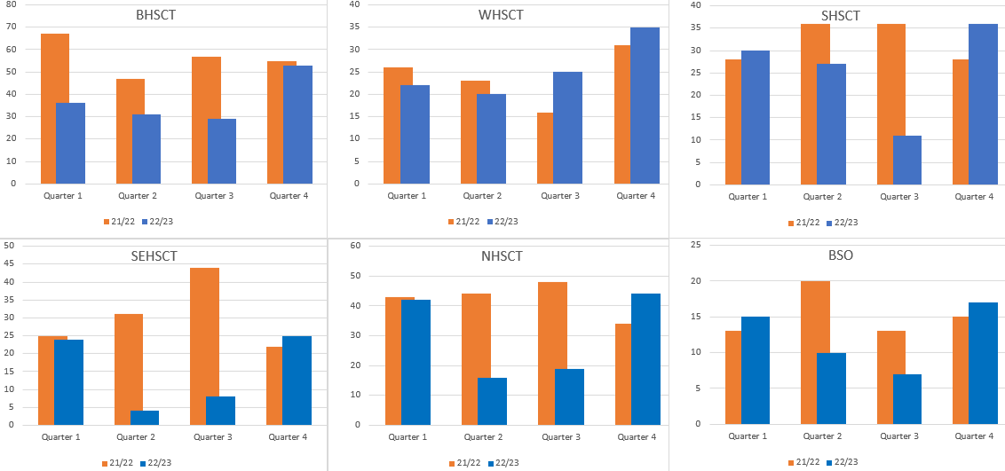

  - GP Practitioner Team
This team administers pension records for all General Medical and Dental Practitioners which includes the verification of GP pension certificates submitted on an annual basis and calculates the rates of Seniority to be paid to eligible Members. The team also administers pension records and provides training and workshops for staff employed in GP Practices and other Directional bodies.

8. McCloud Preparations

HSC Pension Service (HCPS) continues to provide information and guidance to Scheme Members, Employers and other stakeholders on the changes in legislation. Such communication includes Employer Technical updates, Employer and Member Newsletters, updates to the scheme website, McCloud Specific Workshops and development of scheme literature and videos.

- System Development
We continue to work closely with our software suppliers, Heywood Pension Solutions, to ensure our systems are capable of implementing the required legislative changes. Following approval of the McCloud OBC, a number of workshops have already taken place on site with more planned for the year ahead.

- McCloud Business Case
DoF have approved the McCloud Business Case which includes funding for system development and resources for implementation. A workforce development plan is in place and recruitment and training is already underway. A number of staff engagement sessions have been held internally to complete a Training Needs Analysis and identify challenges and proposed solutions.

- Accommodation
HSCPS has been informed that Waterside House will be closing (expected date circa 2025) and all staff including HSCPS staff will be relocated to Orchard House. HSCPS and BSO SMT have requested further information from NICS on accommodation plans.
- SAB Update
- Contractual Change for Management Allowances

HSCPS are working with the DoH and HSC Employers to investigate the option for medical staff who take on a clinical director role (or similar) which attracts a management allowance to have the management allowance element treated as separate contract which would mean that it is a separate contract of employment over and above the members full time contract and therefore is treated as non-pensionable.

In having the management allowance as non-pensionable this would reduce the growth in pension benefits yearly thus reducing the possibility of the member breaching their AA amount. The choice, when made by the member is binding and cannot be changed.
- Amendment of Revaluation Rates
Under current arrangements for calculating growth in benefits there is a timing mismatch between the CPI used to revalue the pension at the start of the year and the CPI used for revaluation of CARE benefits (there is effectively a 1-year lag).
In the last few years, CPI has been relatively stable and so, this has not been particularly noticeable. However, recent high inflation means that this difference has become more acute, leading to more members breaching the annual allowance.
HMT has given GB schemes the option of moving the date that revaluation is applied to CARE pensions from 1 April to 6 April each year. This would essentially align the rate of CPI used in both calculations. DoH is in discussion with DoF regarding making this change for the HSC scheme.
If this is introduced then, as a one off for the 2022/23 tax year, there would be no in-service revaluation in the calculation of the Pension Input Amount (PIA) for schemes which this applies to. This would therefore reduce an individual’s PIA meaning they may be less likely to breach the annual allowance limit.

- HSC Pension Scheme Member Contribution Structure
A new tiered member contribution structure was implemented from 01 November 2022.
Contribution rates are now based on actual pensionable pay instead of members’ notional whole-time equivalent pay. The tiered boundaries will be increased in line with annual AFC pay awards and will be phased over 2 years. The initial 11 tier Contribution structure has been implemented from 01 November 2022. The second phase introducing further amendments to the contribution tier structure and rates will take place on a date to be confirmed in 2023.

- Coronavirus Act 2020
As a result of the Coronavirus Act 2020 a number of temporary adjustments were made to the HSC Pension Scheme Regulations to extend the suspension of abatement rules until 31 October 2022. This has now been further extended to 31st March 2024. The limit on earnings (commonly referred to as abatement) normally imposed on Special Class Nursing Staff or Mental Health Officers on return to HSC employment after retirement has been extended to 31st March 2025.

- Resources
HSCPS utilised the full RRL approved by DoH and successfully achieved a break-even position at year end. There were a number of inescapable pressures in-year however these were funded internally by BSO. HSCPS also received a Satisfactory outcome from BSO Internal Audit and there were no recommendations advised. The implementation of the McCloud Remedy required significant resources for 22/23 and will do so going forward for 23/24 and 24/25. HSCPS submitted a successful OBC for additional resources and this was approved by DoH and DFP.

Appendix A

Record Keeping; data improvement

All public service scheme administrators are obliged to review scheme data regularly and maintain accurate records. HSCPS has various tools in place to ensure full compliance in maintaining common and scheme specific data.
Scheme specific data
Accurate scheme specific data is maintained in the following ways
- monthly and annual interfaces with Payroll Shared Services
- annual and quadrennial full funding valuations with GAD
- bulk Annual Benefit Statement processes
- Annual Allowance process with Pension Input Amounts (PIA’s)
Additionally, HSC Pension Service regularly runs reports across all member records to ensure the accuracy of member data, known as “common data”.
The table below shows the latest data check on 08.11.22 across 340,690 records revealed that 2 National Insurance numbers were missing. Investigations revealed the members were dependants
13296 records were missing a postcode and again, this was due to the member having left the scheme. The correct address and postcode will be obtained once a new pension event has been triggered.

Common Data checks | No of errors / missing data | Reason | Action
NINO | 13 | Dependant members | Records updated
Surname | nil
Forename | nil
Postcode | 13296 | All deferred members/or no liability | No action until a pension event is triggered as member may have changed address
Sex | nil
Date of birth | nil

Appendix B

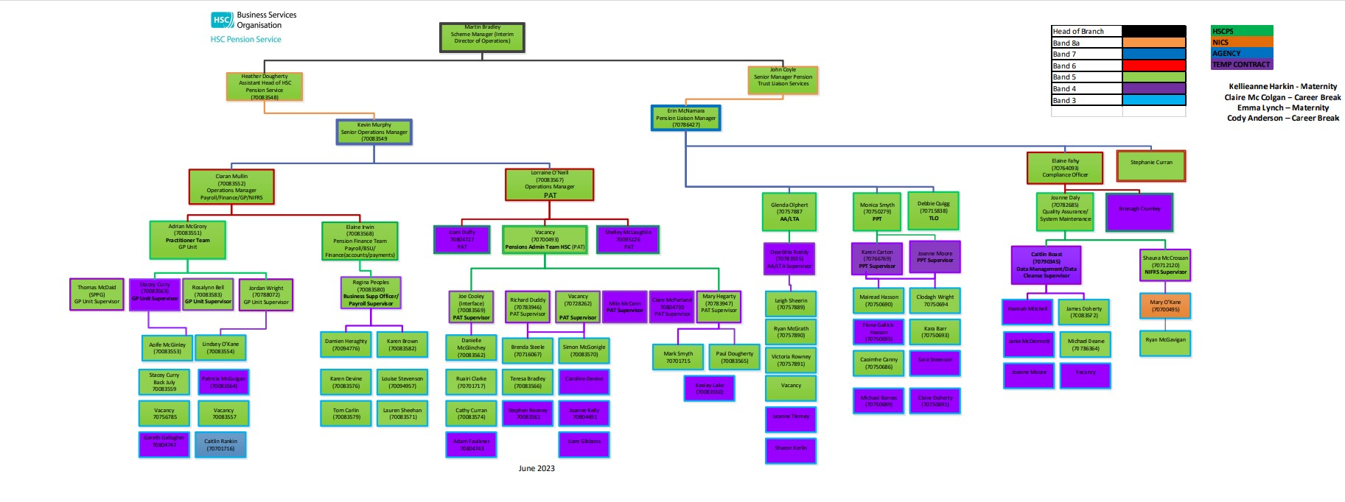
Organisational Chart

- Governance

  - Risk Management
Throughout the year board members received copies of the HSC Risk Register including key risk areas, an assessment of likelihood and impact of the short, medium and long-term risks, threats and opportunities.

The Board has an opportunity to discuss and challenge the risks, and if appropriate, reconsider a risk assessment and the mitigating actions to bring the risk within the HSC Pension Board’s risk appetite.

  - Reporting to The Pensions Regulator (TPR)

The HSC Pension Scheme had no incidents to report to the TPR in this financial year.

3.3 Meetings and Attendance

During the 2022-2023 scheme year, the Pension Board met on four occasions, all held virtually. The Board will endeavor to meet in person at least once per year.

